DESCRIPTION

TreadWell Decorative Chip - Tile Bond by DANCER is a multi-step application of epoxy products where the existing tile substrate is coated rather than removed. This system consists of colored ¼’’ vinyl chip media and a high-wear urethane finish. The total thickness above the existing tile is ⅛”. Once installation is complete, this flooring system matches TreadWell Decorative Chip, shown below.

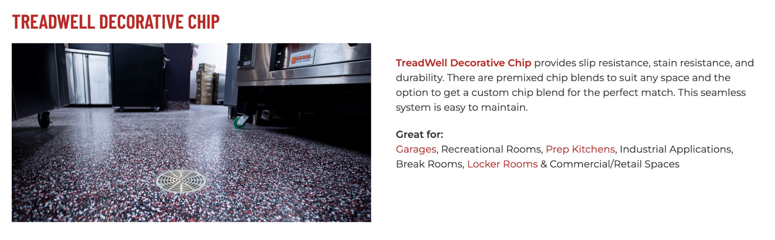

<https://dancerconcrete.com/treadwell-decorative-chip/>

**Durability.** Additional abrasion resistance over solid color epoxy systems.

**Topcoat Options.** Several final finishes available to meet slip resistance or cleaning standards.

**Customization.** Our variety of colors can be matched to your brand.

**Additional Options**

* Flexible primer and base to multi-story, wood, or gypsum based substrates
* 4” or 6” integral cove base

LIMITATIONS: Not to be used in kitchen environments with fryers, or commercial dishwashing equipment. Moderate vehicle traffic applications.

QUICK SPEC

DANCER, TREADWELL DECORATIVE CHIP - TILE BOND

COLOR: SPECIFIED BY ARCHITECT

FINISHED SHEEN: GLOSS, SATIN, OR GLOSS W/GRIP

Contact: Nick Dancer, 260-415-1951

DANCER offers AIA-Accredited Courses for Polished Concrete, Epoxy Coatings, and Terrazzo hosted in your office, our Shop, or online. Please contact us to schedule and for budget pricing, samples, or design considerations.

Nick Dancer. [nickdancer@dancerconcrete.com](mailto:nickdancer@dancerconcrete.com), 260-415-1951.

PART 1 – GENERAL

1.1    SUMMARY

1. Section includes products and procedure for a vinyl chip broadcast flooring system designated area as specified herein as indicated on drawings.
2. The work shall consist of preparation of the concrete substrate, furnishing and application of all of the steps and procedures relating to the installation of this flooring including grout coat, primer, body coat, broadcast, encapsulation coat and a final high-wear topcoat.
3. Cove base, if selected to be noted on the finish schedule. Available in 4” and 6” installation.

1.2    SUBMITTALS

1. Product Data: Manufacturer’s technical literature for each product indicated, specified, or required.
2. Samples: For each type of exposure, finish or color. Sample size minimum 4” x 6”.

1.3    QUALITY ASSURANCE

1. Qualifications: Company experienced in performing work similar in design, products, and extent to scope of this project; with a record of successful in-service performance; and with sufficient production capability, facilities, and personnel to product specified work.
2. Manufacturer Qualification: Approved by manufacturer of epoxy products.

1.4    FIELD CONDITIONS

1. Tile flooring to be available and open for preparation steps. Once the floor is prepared, only allow foot traffic on the exposed surface.
2. Adequate lighting to be provided by the General Contractor or Owner prior to the installation of flooring.
3. Area for installation to be maintained at a temperature between 60 F – 75 F. Area for installation must be in controlled conditions.
4. A sufficient area for staging and mixing materials to be provided.
5. Building to be closed in with no water intrusion on the surface during the installation or curing process.
6. Existing Concrete Surfaces
7. Prohibit improper application of liquid membrane forming curing compounds, vehicles parking over the concrete surface, pipe-cutting operations over concrete surface, storage of items on concrete less than 28 days old, petroleum, oil, hydraulic fluid, and acids as these may all affect final finish of floor treatment.

1.5 WARRANTY

1. DANCER warrants that material and installation is free from defects and will perform substantially.

1. DANCER’s liability with respect to this warranty covers labor and material of the installation for a period of two years.

PART 2 – PRODUCTS

2.1    ACCEPTABLE MANUFACTURES

1. Basis of Design: for products and materials specified from TreadWell Decorative Chip - Tile Bond System by DANCER, Fort Wayne, Indiana. Single source warranty carried by installer. Products of the manufactures are approved provided compliance with all technical requirements as specified herein:
2. DANCER, TreadWell Decorative Chip - Tile Bond, Fort Wayne, IN. Contact Nick Dancer, 260-415-1951, [nickdancer@dancerconcrete.com](mailto:nickdancer@dancerconcrete.com)
3. Dur-A-Flex, Inc.
4. Sherwin Williams High-Performance Flooring Systems

2.1    PRODUCTS

1. Floor Cleaner: Heavy duty, high pH detergent for deep cleaning
2. Grout Coat: Smooth, trowelable underlayment
3. DANCER; TreadWell Tile Bond Grout
4. Primer: Clear, catalyzed, water-based primer to be used on prepared concrete surface at an application rate to seal the surface.
5. DANCER; TreadWell 100% Epoxy Primer, resin and hardener with Tile Bond Additive.
6. Body Coat: Pigmented, 100% solids epoxy body coat applied to coat the surface and provide a base.
7. DANCER; TreadWell 100% Solids Pigmented Epoxy Body Coat, resin and hardener.
8. Broadcast: Multi-colored, ¼” vinyl chip media.
9. DANCER; TreadWell ¼” Vinyl Chip
10. Encapsulation Coat: Clear, 100% solids epoxy coat with UV inhibitors used to encapsulate broadcasted chip media.
11. DANCER; TreadWell 100% Solids UV-Clear Epoxy Coat, resin and hardener.
12. High-Wear Topcoat: Clear, catalyzed, water based urethane to be used over epoxy finish. Finishes available: Gloss, Satin, Satin w/GRIP (for wet areas).
13. DANCER; TreadWell 4:1 Water-Based Urethane

2.3    REPAIR PRODUCTS

1. Repair Mortar: A rapid-setting resin based repair mortar mixed with sand and/or stone aggregate to repair the floor in large cracks, crevices and divots.
2. DANCER; Repair Mortar

PART 3 - EXECUTION

For More Detailed Steps, please call Nick Dancer with DANCER at 260-415-1951 or by email at [nickdancer@dancerconcrete.com](mailto:nickdancer@dancerconcrete.com). Finishing steps vary depending on job site conditions or concrete. Execution section can be written for your specific job.

3.1    EXAMINATION

1. Examine substrates, area and conditions, and any condition that could affect flooring performance.

3.2    PREPARATION

1. General
2. Existing tile surfaces to be free of contaminants that may inhibit proper bonding of porcelain or ceramic tile surface. Tile must be sound and solid. Not compatible with plastic tile, such as VCT.
3. The surface shall be cleaned both mechanically and chemically to remove any residue or debris from tile grout lines.
4. Trowel down the smooth underlayment to fill grout lines
5. Mechanically grind the floor while capturing dust with a HEPA vacuum system to maintain air quality during preparation. Minimum profile must be CSP 3-4 as detailed by ICPI. Any loose tiles to be removed and patched with Repair Mortar.
6. Cracks and non-moving control joints to be repaired per manufacturer's specification. All cold joints to be honored through the installed system and filled with an elastomeric joint filler.
7. Any concrete areas or patches are to be prepared in a similar fashion.

3.3 APPLICATION

1. General
2. The system shall follow the contour of the floor unless noted patching or leveling specified by the Architect.
3. The finish shall have a neat, clean, and organized appearance with straight lines, and well defined boundaries of the installation.
4. Primer
5. The primer shall be TreadWell 100% Solids Epoxy with Tile Bond Additive. The catalyzed product shall be mixed per manufacturer's recommendation.
6. The primer shall be applied by squeegee and roller at the rate of 100 SF per gallon.

1. Base Coat
2. The base coat shall be TreadWell Pigmented 100% Solids Epoxy. The catalyzed product shall be mixed per manufacturer's recommendation.
3. The base coat shall be applied over a cured primer by squeegee and roller at the rate of 200 SF per gallon.
4. Broadcast
5. The broadcast shall be TreadWell multi-colored ¼” vinyl chips.
6. The broadcast shall be performed by an installer on spiked cleats. The broadcast to be applied to the surface until rejection into the ‘wet’ base coat. Excess chip media to be scraped and swept clean once basecoat has fully cured.
7. Encapsulation Coat
8. The encapsulation coat shall be TreadWell UV-Clear 100% Solids Epoxy. The catalyzed product shall be mixed per manufacturer's recommendation.
9. The encapsulation coat shall be applied over the broadcasted chip media by squeegee and roller at the rate of 130 SF per gallon
10. High-wear Topcoat
11. The topcoat shall be TreadWell High-Wear Urethane. The catalyzed product shall be mixed per manufacturer's recommendation.
12. The topcoat shall be applied over a cured primer at the rate of 400 – 500 SF per gallon.

3.3    PROTECTION

1. The flooring shall be allowed to cure for 24 hours before other trades walk on the surface. The floor shall be allowed to cure 48 hours from final topcoat until construction activities or setting of items on the floor. When setting items on the finished surface they shall be placed on cardboard.
2. Covering: After completion of sealing allow for proper cure and then protect sealed floors from subsequent construction activities with protective covering, such as Ram Board or equivalent. No tape to be used on the finished surface.

END OF SECTION 09 67 23