DESCRIPTION

TreadWell Decorative Chip Mortar+ is a heavy-duty flooring system that combines the advantages of a TreadWell Urethane Mortar, such as impact resistance and built-in moisture mitigation, with the aesthetics and easy maintenance of the TreadWell Decorative Chip system. This system is typically specified in restrooms, light-duty prep kitchens, non-cleated locker rooms, and corridors. The total system thickness is 3/16”.

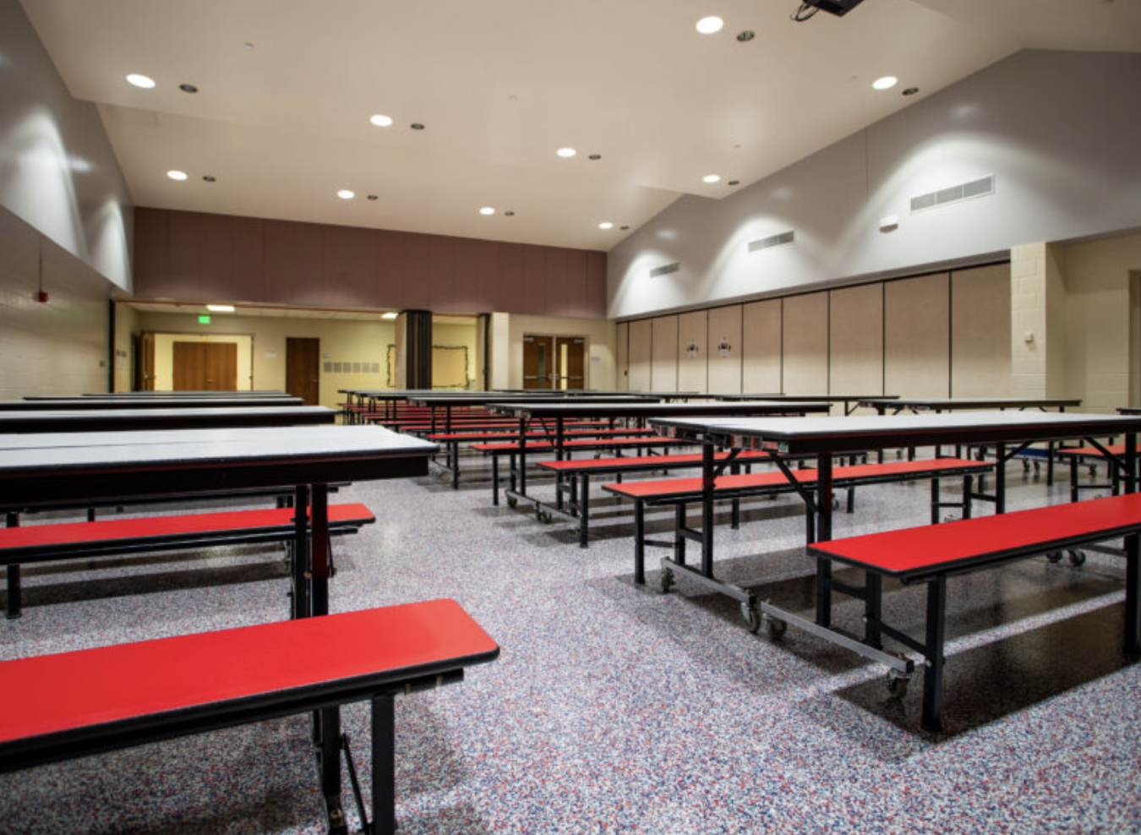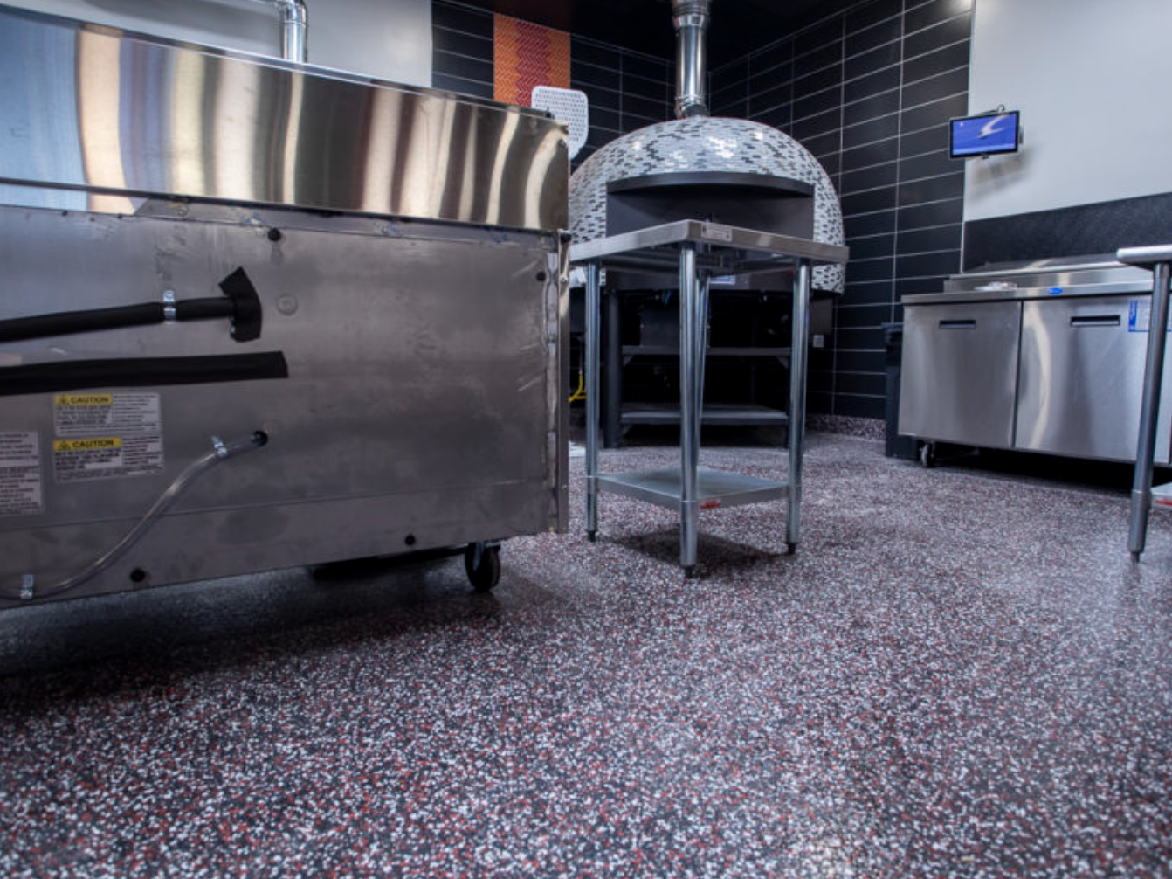

**Moisture Mitigation.** Installs on concrete surfaces up to 99% RH.

**Slip Resistant.** Orange peel finish allows for mop cleaning.

**High-Wear Urethane.** Advanced abrasion resistance with excellent chemical resistance.

**Customization.** Our variety of colors can be matched to your brand.

**Additional Options**

* Flexible membrane for multi-story installations and water-proofing applications
* 4” or 6” integral cove base
* GriP. Add to improve slip resistance in wet areas.
* GriT. Add to improve abrasion resistance.

QUICK SPEC

DANCER, TREADWELL DECORATIVE CHIP MORTAR+

COLOR: TBD BY ARCHITECT FROM MANUFACTURERS FULL RANGE

Contact: Nick Dancer, 260-415-1951

DANCER offers AIA-Accredited Courses for Polished Concrete, Epoxy Coatings, and Terrazzo hosted in your office, our Shop, or online. Please contact us to schedule and for budget pricing, samples, or design considerations.

Nick Dancer. [nickdancer@dancerconcrete.com](mailto:nickdancer@dancerconcrete.com), 260-415-1951.

PART 1 – GENERAL

1.1    SUMMARY

1. Section includes products and procedures for a self-leveling urethane mortar with decorative chip broadcasts system designated area as specified herein as indicated on drawings.
2. The work shall consist of preparation of the concrete substrate, furnishing and application of all of the steps and procedures relating to the installation of this flooring including primer, body coat, broadcast, encapsulation coat and final high-wear topcoat.
3. Cove base, if selected to be noted on the finish schedule. Available in 4” and 6” installation.

1.2    SUBMITTALS

1. Product Data: Manufacturer’s technical literature for each product indicated, specified, or required.
2. Samples: For each type of exposure, finish or color. Sample size minimum 5” x 5”.

1.3    QUALITY ASSURANCE

1. Qualifications: Company experienced in performing work similar in design, products, and extent to scope of this project; with a record of successful in-service performance; and with sufficient production capability, facilities, and personnel to product specified work.
2. Manufacturer Qualification: Approved by manufacturer of epoxy products.

1.4    FIELD CONDITIONS

1. Concrete flooring to be available and open for preparation steps. Once the floor is prepared, only allow foot traffic on the exposed surface.
2. Adequate lighting to be provided by the General Contractor or Owner prior to the install of flooring.
3. Area for installation to be maintained at a temperature between 60F – 75F. Area for installation must be in controlled conditions.

1. A sufficient area for staging and mixing materials to be provided.
2. Building to be closed in with no water intrusion on the surface during the installation or curing process.
3. Existing Concrete Surfaces
4. Prohibit improper application of liquid membrane forming curing compounds, vehicles parking over the concrete surface, pipe-cutting operations over concrete surface, storage of items on concrete less than 28 days old, petroleum, oil, hydraulic fluid, and acids as these may all affect final finish of floor treatment.

1.5 WARRANTY

1. DANCER warrants that material and installation is free from defects and will perform substantially.
2. DANCER’s liability with respect to this warranty covers labor and material of the installation for a period of five years.

PART 2 – PRODUCTS

2.1    ACCEPTABLE MANUFACTURES

1. Basis of Design: for products and materials specified from TreadWell Decorative Chip Mortar+ System by DANCER, Fort Wayne, Indiana. Single source warranty carried by installer. Products of the manufactures are approved provided compliance with all technical requirements as specified herein:
2. DANCER, TreadWell Decorative Chip Mortar+, Fort Wayne, IN. Contact Nick Dancer, 260-415-1951, [nickdancer@dancerconcrete.com](mailto:nickdancer@dancerconcrete.com)
3. Dur-A-Flex, Inc
4. Sherwin Williams High-Performance Flooring Systems

2.1    PRODUCTS

1. Mortar: Self-Leveling, three-part mortar base coat
2. DANCER: TreadWell Mortar
3. Broadcast: Multi-colored, ¼” vinyl chip media
4. DANCER: Torginol Polymer Flakes
5. Body Coat: Clear, 100% solids epoxy body coat applied to the surface as a base for the decorative chip broadcast.
6. DANCER: TreadWell 100% Solids Clear Epoxy Body Coat, resin, and hardener
7. Encapsulation Coat: Clear, 100% solids epoxy coat with UV inhibitors epoxy used to encapsulate broadcasted media.
8. DANCER: TreadWell 100% UV-Clear Epoxy Top Coat, resin and hardener
9. High-Wear Topcoat: Clear, catalyzed, water based urethane to be used over epoxy finish.
10. DANCER TreadWell High-Wear Urethane

Finishes available: Gloss Grit, Satin grit, Satin Grit w/GRIP (For wet areas)

2.3    REPAIR PRODUCTS

1. Repair Mortar: A rapid-setting resin based repair mortar mixed with sand and/or stone aggregate to repair the floor in large cracks, crevices and divots.
2. DANCER; Repair Mortar

PART 3 - EXECUTION

For More Detailed Steps, please call Nick Dancer with DANCER at 260-415-1951 or by email at [nickdancer@dancerconcrete.com](mailto:nickdancer@dancerconcrete.com). Finishing steps vary depending on job site conditions or concrete. Execution section can be written for your specific job.

3.1    EXAMINATION

1. Examine substrates, area and conditions, regarding moisture content, installation and any condition that could affect flooring performance.

3.2    PREPARATION

1. General
2. New and existing concrete surfaces to be free of contaminants that may inhibit proper bonding to concrete surface. No acrylic concrete sealers to be used as a curing agent.
3. The surface shall be mechanically profiled by shot blasting or grinding equipped with a HEPA vacuum system to maintain air quality during preparation. Minimum profile must be CSP 3-4 as detailed by ICPI.
4. Cracks and non-moving control joints to be repaired per manufacturer's specification. All cold joints to be honored through the installed system and filled with an elastomeric joint filler.

3.3 APPLICATION

1. General
2. The system shall follow the contour of the floor unless noted patching or leveling specified by the Architect.
3. The finish shall have a neat, clean, and organized appearance with straight lines, and well defined boundaries of the installation.
4. Mortar Base
5. The mortar shall be TreadWell Mortar. The catalyzed product shall be mixed per manufacturer's recommendation.
6. Application to be 50 SF per mixed kit.
7. A ¼” vinyl chip media shall be broadcast into the wet mortar at the rate of .1 lb per SF.
8. Broadcast Coat
9. This system requires two broadcasts.
10. The body coat shall be TreadWell 100% Solids Clear Epoxy Body Coat. The catalyzed product shall be mixed per manufacturer’s recommendation.
11. The body coat shall be applied by squeegee and roller at the rate of 100 SF per gallon.
12. The broadcast shall be ¼” vinyl chip media.
13. The broadcast shall be performed by an installer on spiked cleats. The broadcast is to be applied to the surface until rejection into the ‘wet’ base coat. The application is .1 lbs. of vinyl chips per SF
14. Excess chip media is to be scraped and swept clean once the body coat has fully cured.

D. Encapsulation Coat

1. The encapsulation coat shall be TreadWell UV-Clear 100% Solids Epoxy. The catalyzed product shall be mixed per the manufacturer’s recommendation.
2. The encapsulation coat shall be applied over the chips leaving an even stipple texture with no puddles or smooth spots at the rate of 130 SF per gallon.

E. High-Wear Topcoat

1. The topcoat shall be TreadWell High-Wear Urethane. The catalyzed product shall be mixed per the manufacturer’s recommendation.
2. The topcoat shall be applied by roller at the rate of 400 SF per gallon.

3.3    PROTECTION

1. The flooring shall be allowed to cure for 24 hours before other trades walk on the surface. The floor shall be allowed to cure 48 hours from final topcoat until construction activities or setting of items on the floor. When setting items on the finished surface they shall be placed on cardboard.
2. Covering: After completion of sealing allow for proper cure and then protect sealed floors from subsequent construction activities with protective covering, such as Ram Board or equivalent. No tape to be used on the finished surface.

END OF SECTION 09 67 23