DESCRIPTION

TreadWell Industrial+ Mortar is a heavy-duty flooring system designed for the most abusive settings. It consists of a solid-color urethane mortar basecoat beneath a self-leveling epoxy and is finished with a high-wear urethane topcoat. It provides the highest level of impact and chemical resistance, as well as excellent scratch resistance. Unlike other systems, it can be installed on “green” concrete without priming, offering quicker installation.

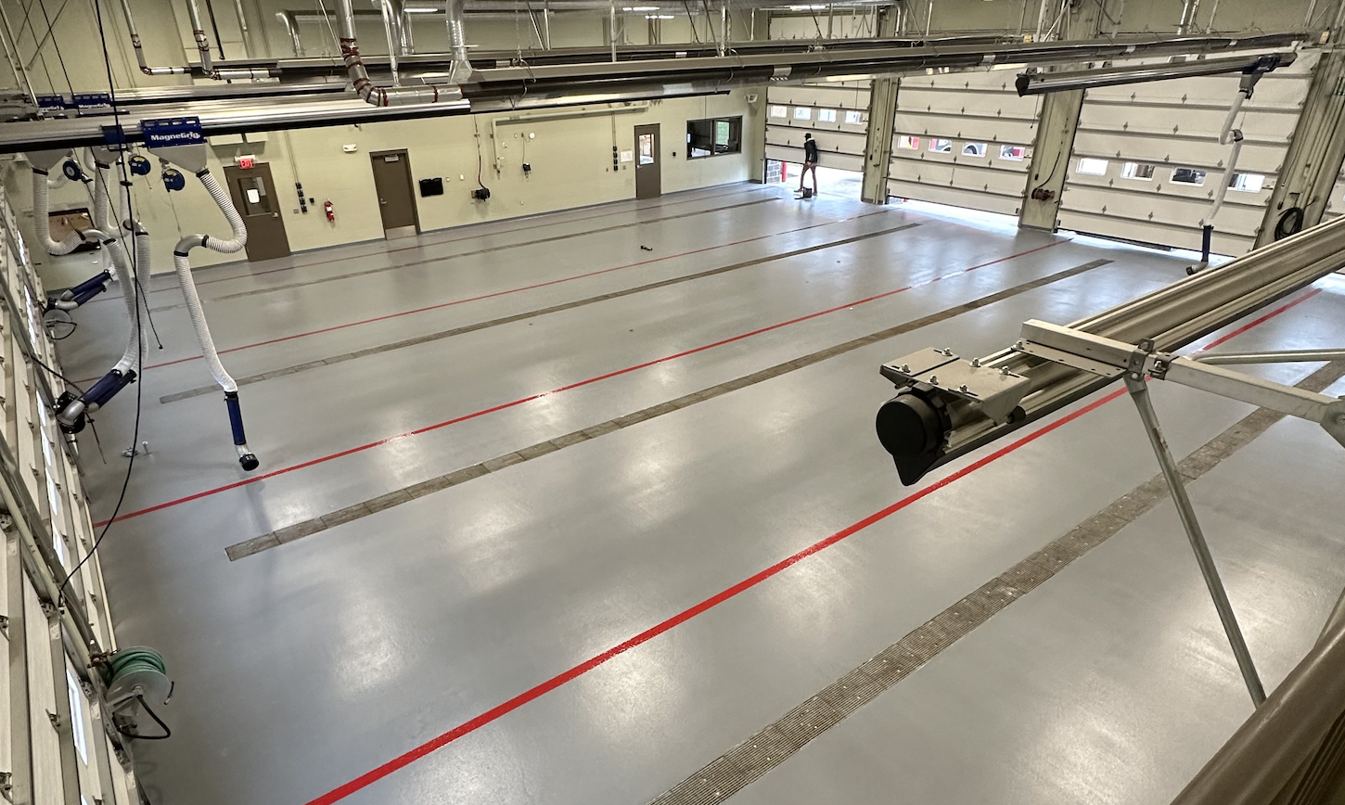

**Thermal Shock.** Ability to withstand temperature swings from ovens or steam cleaning.

**Impact Resistance.** Prevents chipping from drops and falls.

**Moisture Mitigation.** Installs on concrete surfaces up to 99% RH.

**Chemical Resistance.** Various topcoat options for any environment.

**Additional Options**

* Flexible membrane for multi-story installations and water-proofing applications
* 4” or 6” integral cove base

QUICK SPEC

DANCER, TREADWELL INDUSTRIAL+ MORTAR

COLOR: TBD BY ARCHITECT FROM MANUFACTURER’S FULL RANGE

Contact: Nick Dancer, 260-415-1951

DANCER offers AIA-Accredited Courses for Polished Concrete, Epoxy Coatings, and Terrazzo hosted in your office, our Shop, or online. Please contact us to schedule and for budget pricing, samples, or design considerations.

Nick Dancer. [nickdancer@dancerconcrete.com](mailto:nickdancer@dancerconcrete.com), 260-415-1951.

PART 1 – GENERAL

1.1    SUMMARY

1. Section includes products and procedure for a self-leveling urethane mortar system for designated area as specified herein as indicated on drawings.
2. The work shall consist of preparation of the concrete substrate, furnishing and application of all of the steps and procedures relating to the installation of this flooring including primer, body coat, broadcast, self-leveling encapsulation coat and final high-wear topcoat.
3. Cove base, if selected to be noted on the finish schedule. Available in 4” and 6” installation.

1.2    SUBMITTALS

1. Product Data: Manufacturer’s technical literature for each product indicated, specified, or required.
2. Samples: For each type of finish or color. Sample size minimum 4” x 6”.

1.3    QUALITY ASSURANCE

1. Qualifications: Company experienced in performing work similar in design, products, and extent to scope of this project; with a record of successful in-service performance; and with sufficient production capability, facilities, and personnel to product specified work.
2. Manufacturer Qualification: Approved by manufacturer of epoxy products.

1.4    FIELD CONDITIONS

1. Concrete flooring to be available and open for preparation steps. Once the floor is prepared, only allow foot traffic on the exposed surface.
2. Adequate lighting to be provided by the General Contractor or Owner prior to the install of flooring.
3. Area for installation to be maintained at a temperature between 60F – 75F. Area for installation must be in controlled conditions.

1. A sufficient area for staging and mixing materials to be provided.
2. The building is to be closed in with no water intrusion on the surface during the installation or curing process.
3. Existing Concrete Surfaces
4. Prohibit improper application of liquid membrane forming curing compounds, vehicles parking over the concrete surface, pipe-cutting operations over concrete surface, storage of items on concrete less than 28 days old, petroleum, oil, hydraulic fluid, and acids as these may all affect final finish of floor treatment.

1.5 WARRANTY

1. DANCER warrants that material and installation is free from defects and will perform substantially.
2. DANCER’s liability with respect to this warranty covers labor and material of the installation for a period of five years.

PART 2 – PRODUCTS

2.1    ACCEPTABLE MANUFACTURES

1. Basis of Design: for products and materials specified from TreadWell Industrial+ Mortar Epoxy System by DANCER, Fort Wayne, Indiana. Single source warranty carried by installer. Products of the manufactures are approved provided compliance with all technical requirements as specified herein:
2. DANCER, TreadWell Industrial+ Mortar, Fort Wayne, IN. Contact Nick Dancer, 260-415-1951, [nickdancer@dancerconcrete.com](mailto:nickdancer@dancerconcrete.com)
3. Dur-A-Flex, Inc
4. Sherwin Williams High-Performance Flooring Systems

2.1    PRODUCTS

1. Mortar: Self-Leveling, three-part urethane mortar base.
2. DANCER; TreadWell Mortar
3. Self-Leveling Slurry: four-part mixture
4. DANCER; TreadWell Self-Leveling Slurry
5. Topcoat
6. DANCER; TreadWell High-Wear Urethane Topcoat

2.3    REPAIR PRODUCTS

1. Repair Mortar: A rapid-setting resin based repair mortar mixed with sand and/or stone aggregate to repair the floor in large cracks, crevices and divots.
2. DANCER; Repair Mortar

PART 3 - EXECUTION

For More Detailed Steps, please call Nick Dancer with DANCER at 260-415-1951 or by email at [nickdancer@dancerconcrete.com](mailto:nickdancer@dancerconcrete.com). Finishing steps vary depending on job site conditions or concrete.

3.1    EXAMINATION

1. Examine substrates, area and conditions, regarding moisture content, installation and any condition that could affect flooring performance.

3.2    PREPARATION

1. General
2. New and existing concrete surfaces to be free of contaminants that may inhibit proper bonding of concrete surfaces. No acrylic concrete sealers to be used as a curing agent.
3. The surface shall be mechanically profiled by shot blasting or grinding equipped with a HEPA vacuum system to maintain air quality during preparation. Minimum profile must be CSP 3-4 as detailed by ICPI.
4. Cracks and non-moving control joints to be repaired per manufacturer's specification. All cold joints to be honored through the installed system and filled with an elastomeric joint filler.

3.3 APPLICATION

1. General
2. The system shall follow the contours of the floor unless otherwise specified.
3. The finish shall have a neat, clean, and organized appearance with crisp lines and well defined boundaries of the installation.
4. Mortar
5. The mortar shall be TreadWell Mortar. The catalyzed product shall be mixed per the manufacturer's recommendation.
6. Application to be 50 to 55 SF per mixed kit.
7. A flint shot aggregate shall be broadcast into the wet mortar at the rate of 1lb per SF.
8. Self-Leveling Slurry
9. The mortar shall be TreadWell Self-Leveling Slurry. The catalyzed product shall be mixed per the manufacturer's recommendation.
10. Application to be applied at 60 mils.
11. Topcoat
12. The topcoat shall be TreadWell High-Wear Urethane Topcoat. The catalyzed product shall be mixed per the manufacturer's recommendation.
13. Application to be 575 to 825 SF per mixed kit.

3.3    PROTECTION

1. The flooring shall be allowed to cure for 24 hours before other trades walk on the surface. The floor shall be allowed to cure 48 hours from final topcoat until construction activities or setting of items on the floor. When setting items on the finished surface they shall be placed on cardboard.
2. Covering: After completion of sealing allow for proper cure and then protect sealed floors from subsequent construction activities with protective covering, such as Ram Board or equivalent. No tape to be used on the finished surface.

END OF SECTION 09 67 23